**Project Title: Bank Loan Performance Analysis**

The dataset "bank loan.xlsx" contains two sheets:

1. LoanDetails: This sheet contains information about each loan.

2. BorrowerDetails: This sheet provides details about the borrowers.

**Project Steps and Objectives:**

**1) Importing Data**

➢ Import the "LoanDetails" and "BorrowerDetails" sheets from the "bank loan.xlsx" file into Power BI.

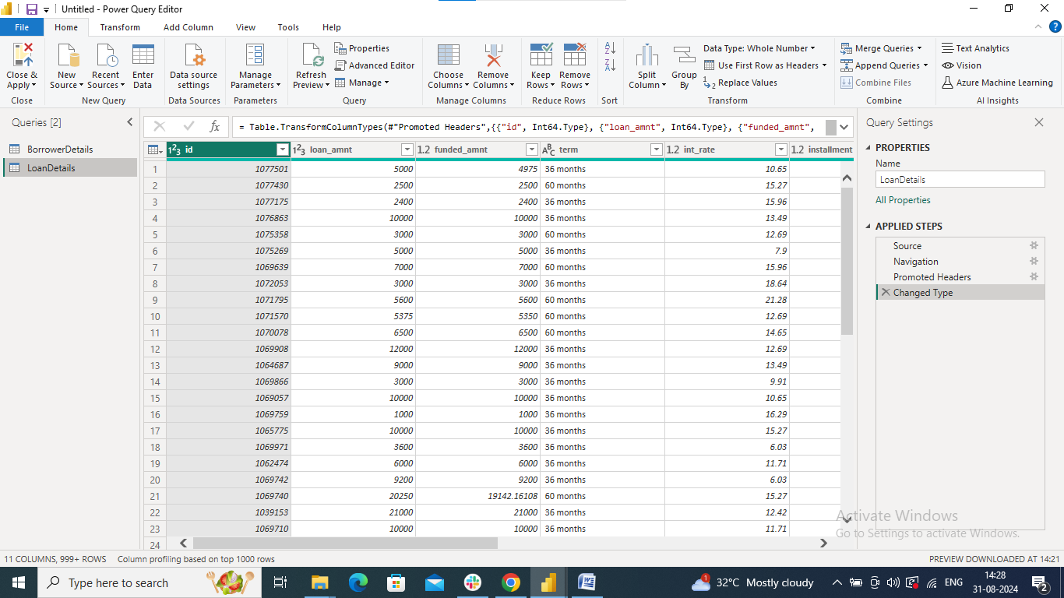

**2) Transformation Using Power Query**

**Data Cleaning:**

**Handling Missing Values and Duplicates:**

➢ Replace missing values (null) in the 'emp_length' column of the "BorrowerDetails" table with '0 year'.

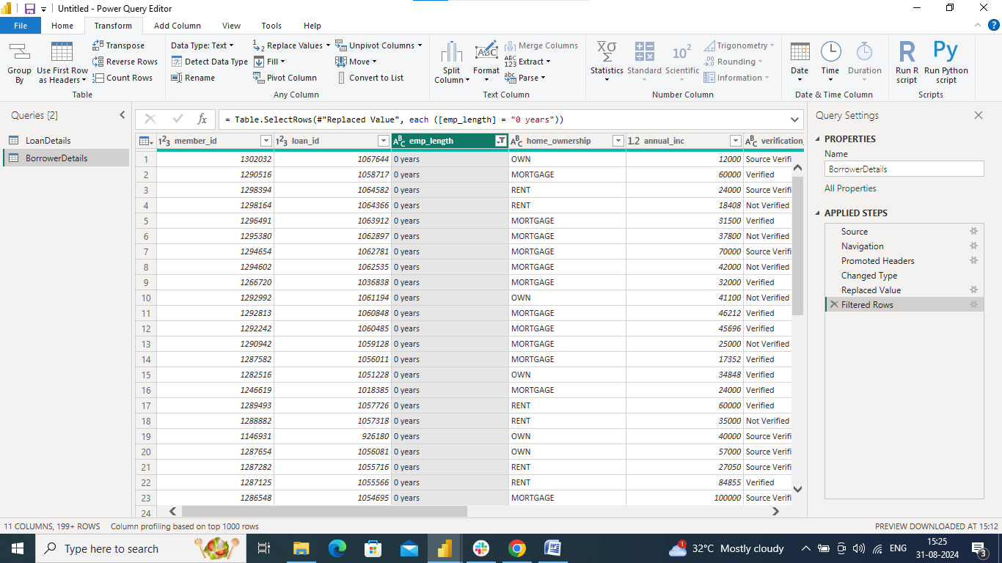

➢ Remove rows with missing values in the 'last_pymnt_d' and 'delinq_2yrs' columns.

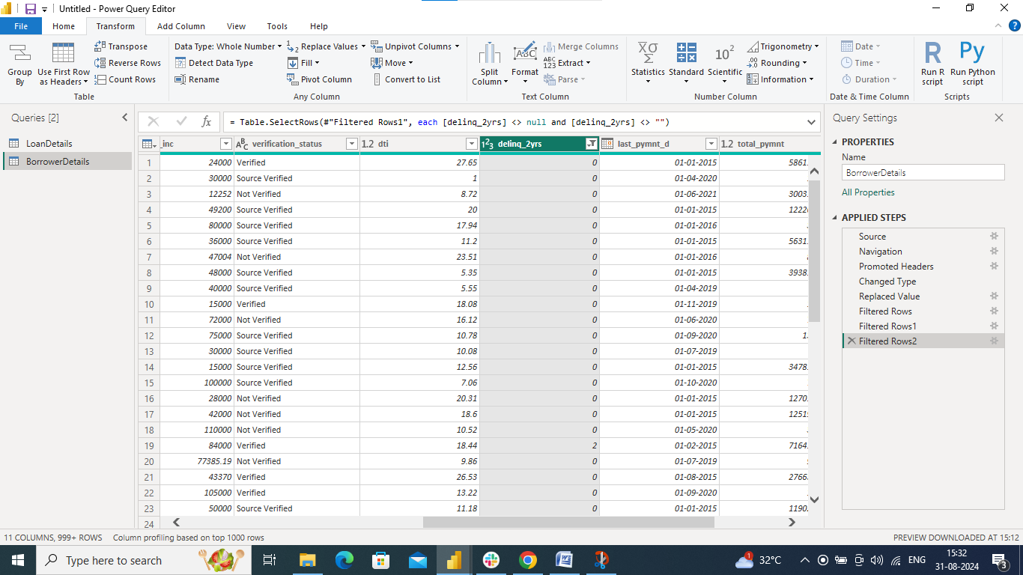

➢ Remove duplicate rows in the 'id' column of the "LoanDetails" table.

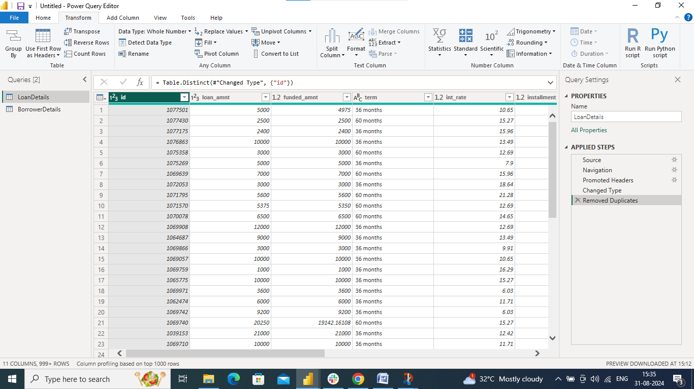

**Dealing with Inconsistencies:**

➢ Ensure words in the 'purpose' column are separated by spaces instead of

underscores (e.g., "credit card" instead of "credit_card").

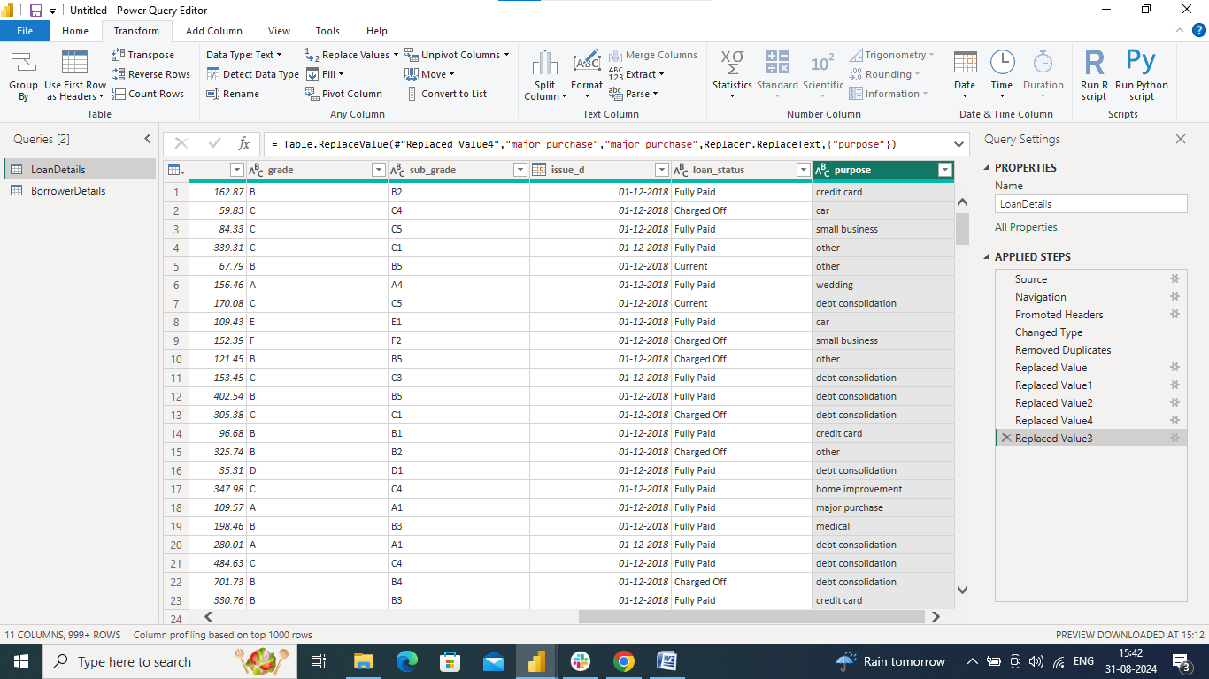

➢ Format the 'purpose' and 'home_ownership' columns to proper case.

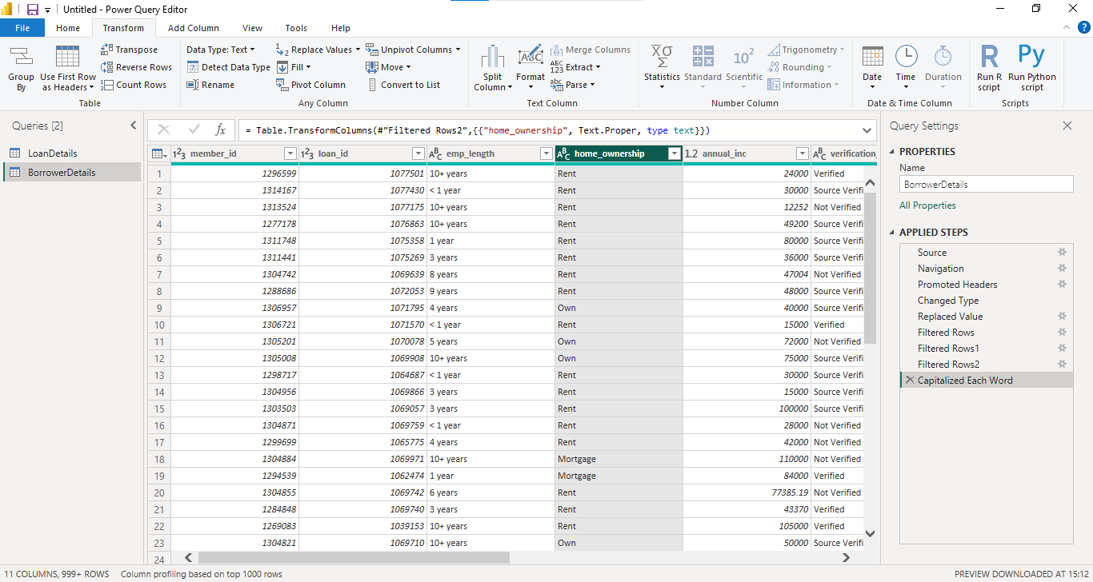

**Data Transformation:**

**Column Transformation:**

➢ Change the data type of the 'total_pymnt' column to 'Fixed decimal number'.

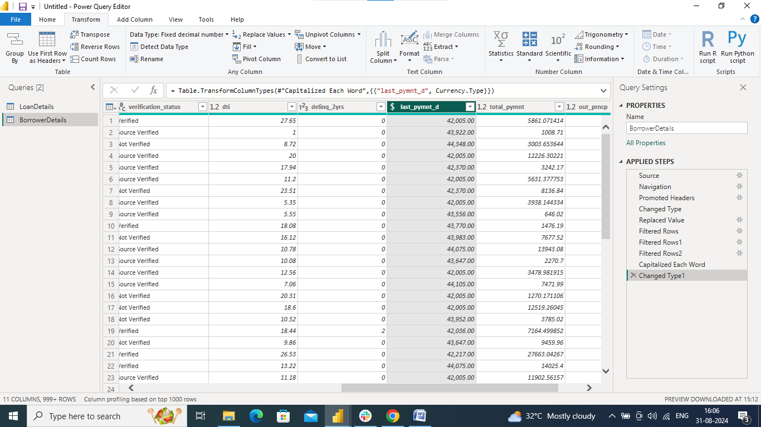

➢ Round off the numbers in the 'funded_amnt' column to 2 decimal places.

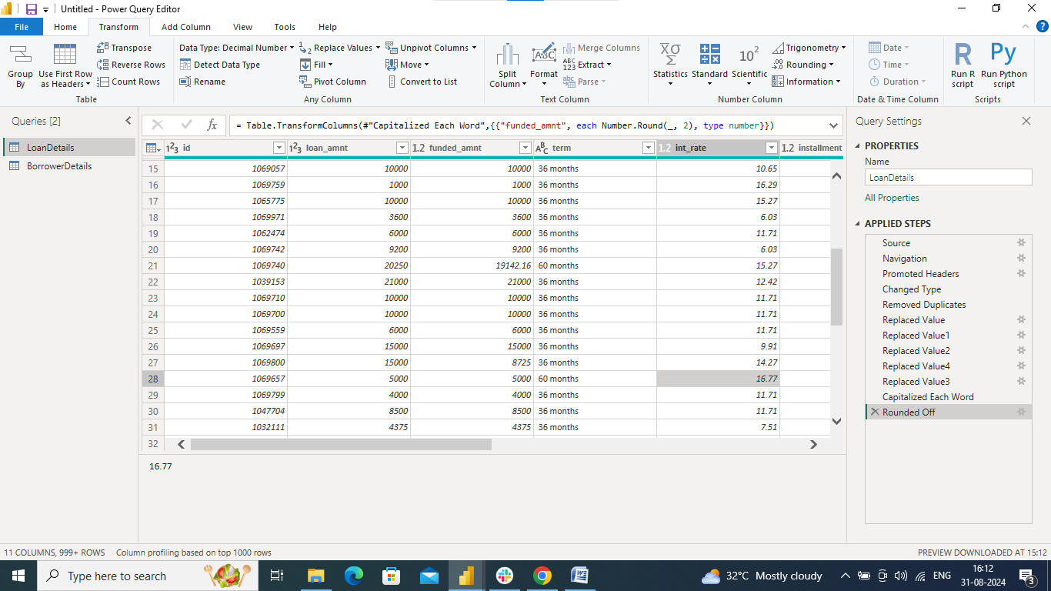

**Column Renaming:**

➢ Rename the column 'issue_d' to 'issue_date'.

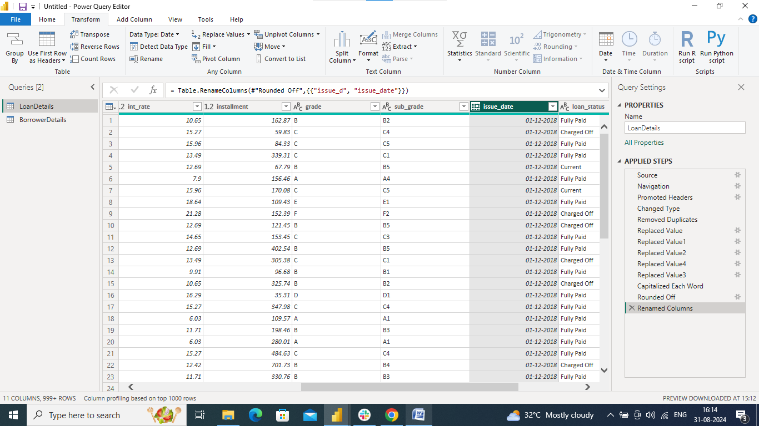

➢ Rename the column 'last_pymnt_d' to 'last_pymnt_date'.

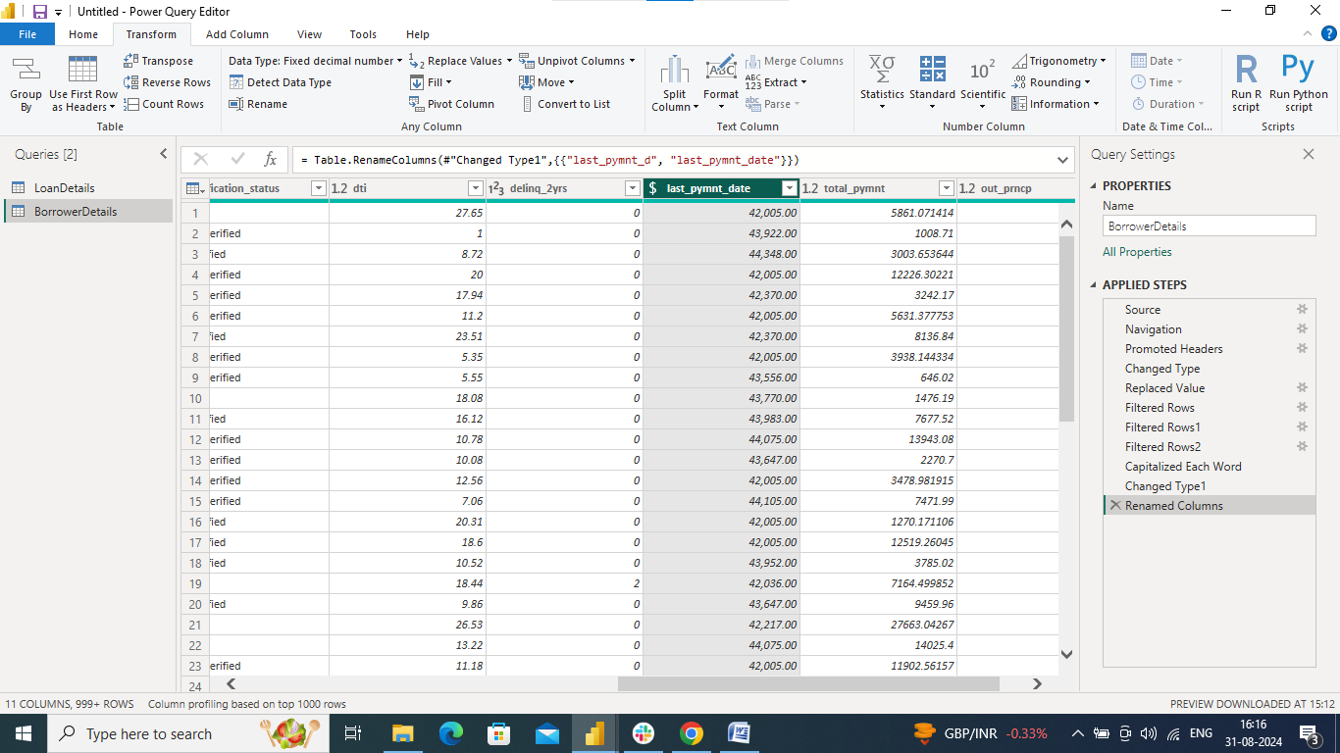

**Creating New Columns:**

➢ Create a new custom column named 'total_amount_paid' to calculate the total

amount paid by each borrower by subtracting 'out_prncp' from 'total_pymnt'.

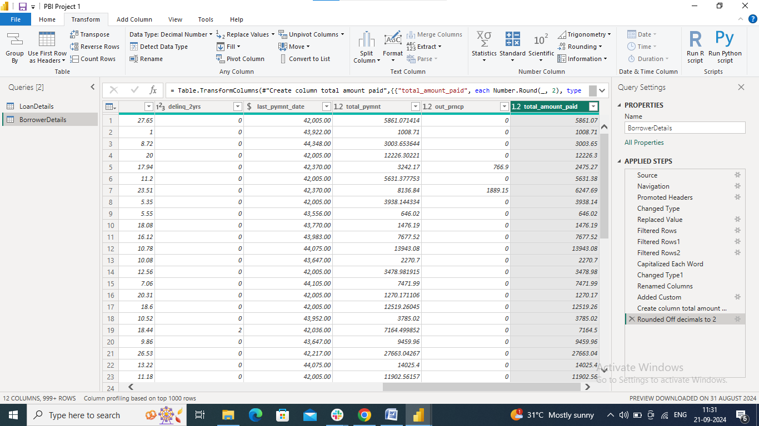

➢ Add a new conditional column named 'delinquency_status' to identify if the

borrower has any delinquencies. If the number of delinquencies in 'delinq_2yrs' is

greater than 0, the status should be "Delinquent", otherwise "Not Delinquent".

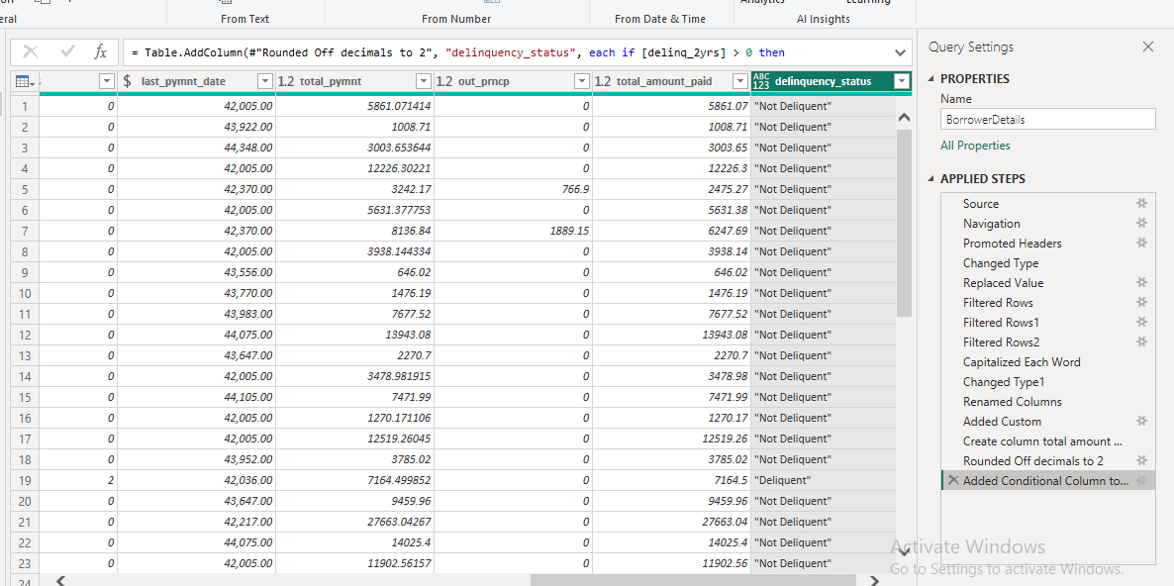

**Column Dropping:**

➢ Remove the 'sub_grade' column as that does not significantly contribute to the

analysis.

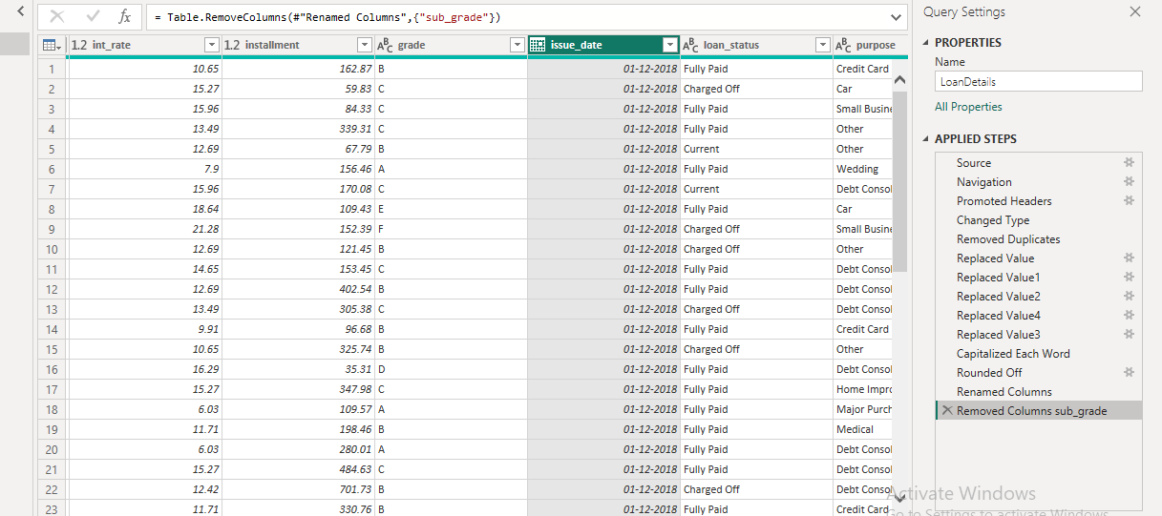

**3) Data Modeling**

➢ Identify the common column between both the tables and establish relationships

between the two tables. Ensure the cross-filter direction is set to "Both". This step

is crucial for enabling cross-table analysis and ensuring data integrity within the

dataset.

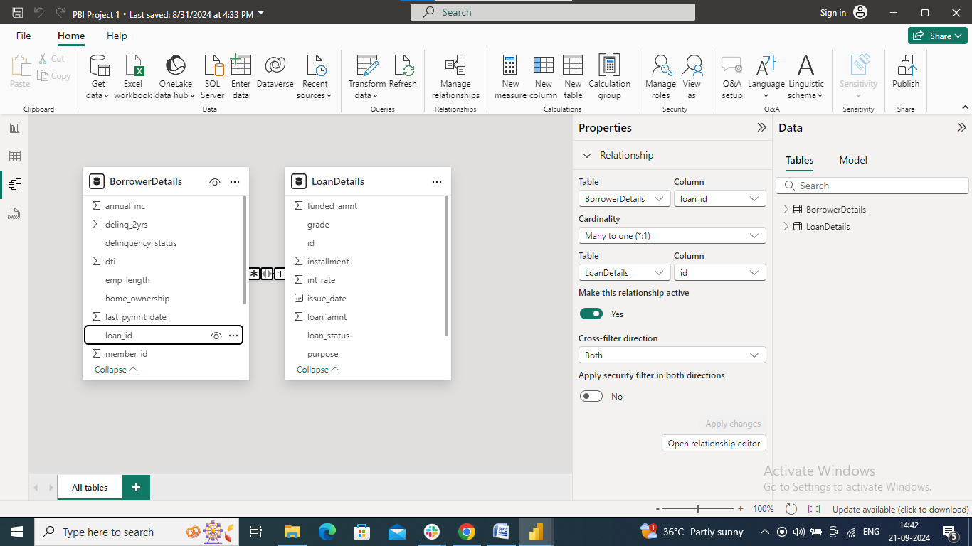

**4) Creating Measures and Calculated Columns using DAX**

➢ Create a new calculated column named 'remaining_installments' using DAX in the "BorrowerDetails" table to calculate the number of remaining installments by

dividing the remaining principal amount ('out_prncp') by the monthly installment

amount ('installment') and round up the result using the CEILING() function to

account for any partial payments.

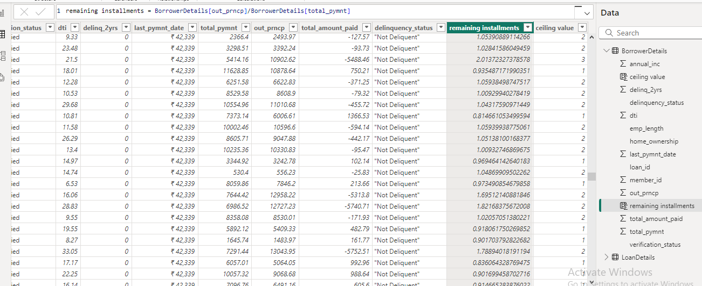

➢ Create a measure named 'Non-Verified Borrowers Count' using DAX to count the number of loans that have been 'Not Verified'.

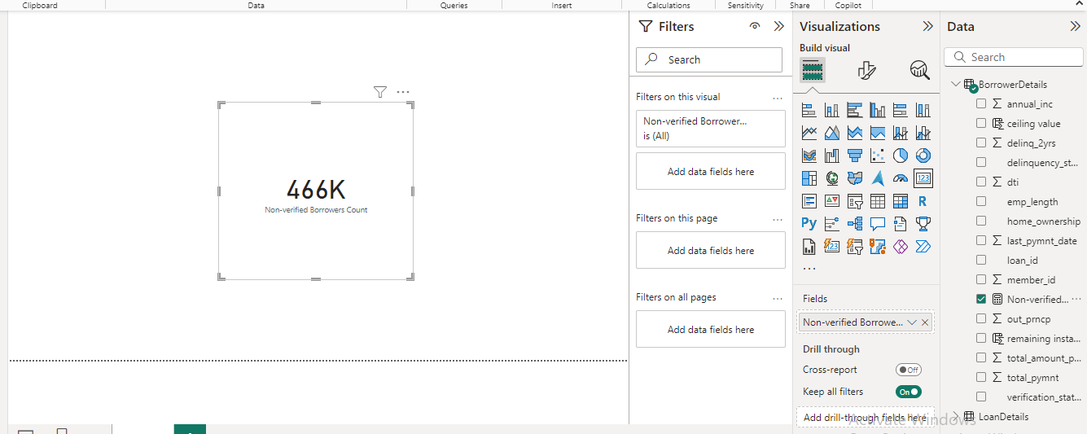

.

**5) Creating Comprehensive Reports**

**★ Report 1: Loan Performance Analysis**

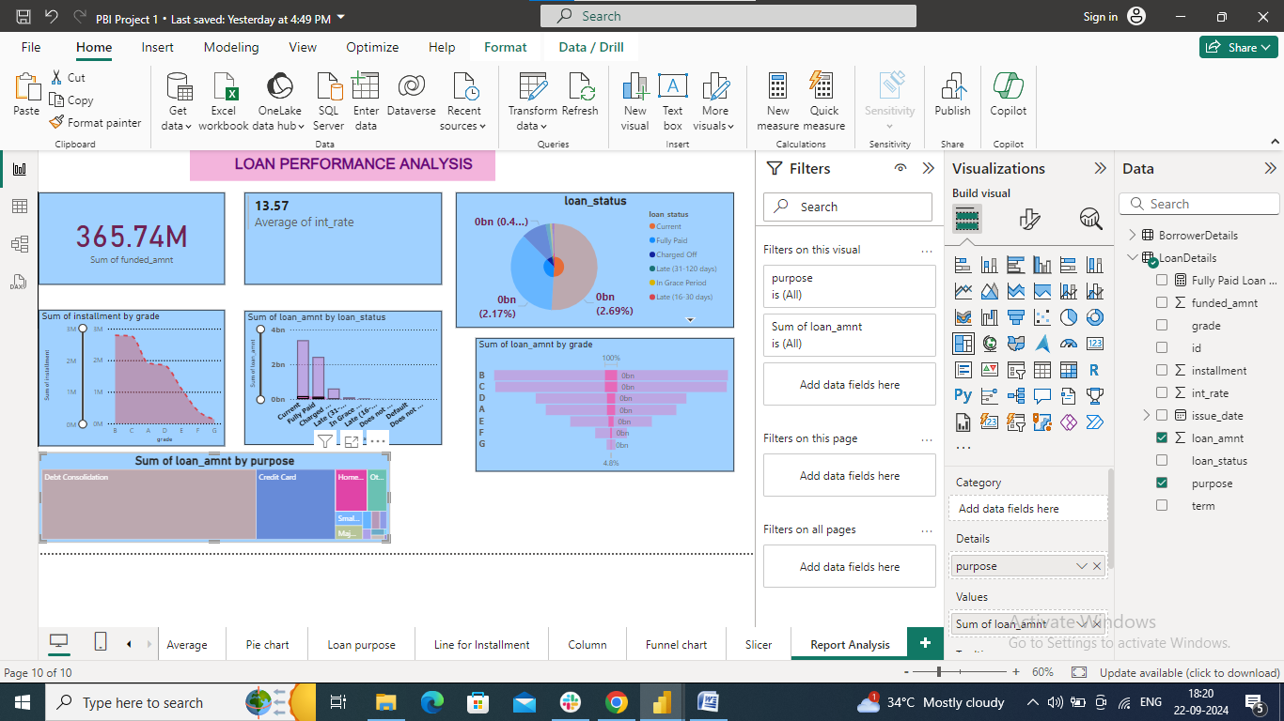

**★ Report 2: Borrower Profile Analysis**

